**PART B :**

**USE CASE: Develop an application to perform Plotting Probabilities Using Matplotlib**

**Matplotlib Python Plotting Ways (Types)**

There are various plotting techniques or ways that can be carried out on the data provided, and some of these plotting types are as follows

**Line Plot**

The plotting of the frequency of data along a line can be represented using a line plot. It is one of the simplest and commonly used plotting methods. Line plotting is a primitive plotting technique as it is a plotting method that was first introduced.

Let us now look at a real-time scenario:

Consider that a survey has to be done on how much distance the following vehicles have covered in a span of five days. The data collected can be plotted in different plotting methods.

We will make use of Jupyter Notebook to run the codes to represent the following data in plot

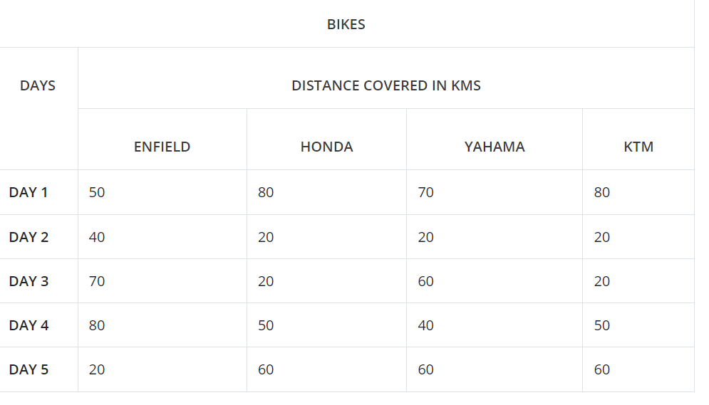

Example for a line plot:

import matplotlib.pyplot as plt

x = [1,2,3,4,5]

y = [50,40,70,80,20]

y2 = [80,20,20,50,60]

y3 = [70,20,60,40,60]

y4 = [80,20,20,50,60]

plt.plot(x,y,’g’,label=’Enfield’, linewidth=5)

plt.plot(x,y2,’c’,label=’Honda’,linewidth=5)

plt.plot(x,y3,’k’,label=’Yahama’,linewidth=5)

plt.plot(x,y4,’y’,label=’KTM’,linewidth=5)

plt.title(‘bike details in line plot’)

plt.ylabel(‘ Distance in kms’)

plt.xlabel(‘Days’)

plt.legend()

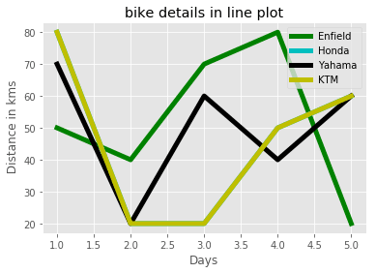

Various lines present in the above graph have unique colors, and each of them denotes details of different bikes. The line representing Honda is overwritten by the line representing KTM, since both vehicles have covered the same distance in their respective days.

Bar Chart Plot

Categorical data can be represented in rectangular blocks with different heights or lengths proportional to the values. Such a type of representation is called a bar chart. Bar charts can be used to plot data in both vertical and horizontal manner.

Example for a bar plot:

import matplotlib.pyplot as plt

plt.bar([0.25,1.25,2.25,3.25,4.25],[50,40,70,80,20],

label=”Enfield”,width=.5)

plt.bar([0.26,1.25,2.25,3.25,4.25],[80,20,20,50,60],

label=”Honda”, color=’r’,width=.5)

plt.bar([0.31,1.5,2.5,3.5,4.5],[70,20,60,40,60],

label=”Yamaha”, color=’y’,width=.5)

plt.bar([.75,1.75,2.75,3.75,4.75],[80,20,20,50,60],

label=”KTM”, color=’g’,width=.5)

plt.legend()

plt.xlabel(‘Days’)

plt.ylabel(‘Distance (kms)’)

plt.title(‘Bikes details in BAR PLOTTING’)

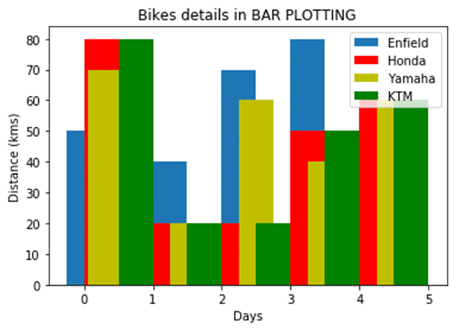

Area Plot

This type of plotting is basically used for quantitative data. A line chart forms the basis of an area plot, where the region between the axis and the line is represented by colors.

Example for an area plot:

import matplotlib.pyplot as plt

days = [1,2,3,4,5]

Enfield =[50,40,70,80,20]

Honda = [80,20,20,50,60]

Yahama =[70,20,60,40,60]

KTM = [80,20,20,50,60]

plt.plot([],[],color=’k’, label=’Enfield’, linewidth=5)

plt.plot([],[],color=’c’, label=’Honda’, linewidth=5)

plt.plot([],[],color=’y’, label=’Yahama’, linewidth=5)

plt.plot([],[],color=’m’, label=’KTM’, linewidth=5)

plt.stackplot(days, Enfield, Honda, Yahama, KTM, colors=[‘k’,’c’,’y’,’m’])

plt.xlabel(‘Days’)

plt.ylabel(‘Distance in kms’)

plt.title(‘Bikes deatils in area plot’)

plt.legend()

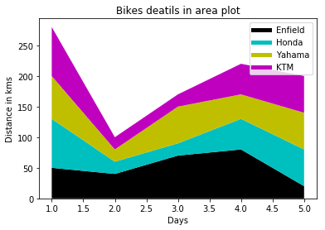

The above represented graph shows how an area plot can be plotted for the present scenario. Each shaded area in the graph shows a particular bike with the frequency variations denoting the distance covered by the bike on different days.

3D Plot

Plotting of data along x, y, and z axes to enhance the display of data represents the 3-dimensional plotting. 3D plotting is an advanced plotting technique that gives us a better view of the data representation along the three axes of the graph.

Example for a 3D plot:

import matplotlib.pyplot as plt

from mpl_toolkits.mplot3d import Axes3D

fig = plt.figure()

ax = fig.add_subplot(111, projection=’3d’)

x = [1,2,3,4,5]

y = [50,40,70,80,20]

y2 = [80,20,20,50,60]

y3 = [70,20,60,40,60]

y4 = [80,20,20,50,60]

plt.plot(x,y,’g’,label=’Enfield’, linewidth=5)

plt.plot(x,y2,’c’,label=’Honda’,linewidth=5)

plt.plot(x,y3,’k’,label=’Yahama’,linewidth=5)

plt.plot(x,y4,’y’,label=’KTM’,linewidth=5)

plt.title(‘bike details in line plot’)

plt.ylabel(‘ Distance in kms’)

plt.xlabel(‘Days’)

plt.legend()

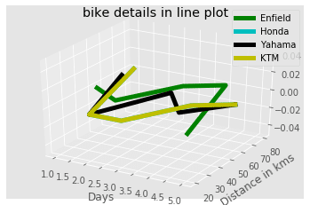

The above histogram shows the step fill pattern. There are various types that can be used, such as bar, step, step fill, etc. The histogram does not include spaces between the blocks. It is a continuous structure denoting the distance count which is the number of times the same distance is covered within a span of five days by the bikes along the Y-axis and the Distance in km along the X-axis.